My Traumatic Brain Injury
Happy Holidays!

4th Qtr.
Newsletter

  - By: Tammy Wuertley, ACP

Board of Directors
• • •
Barbara Heisner, CP
President

Amanda Nelson, ACP
President Elect

Annette Sause
1st Vice President

Kathy Lackey
2nd Vice President

Kapri Scoffield
Secretary

Jayme Bjorklund, ACP
Treasurer

Wendy Trembath, CP
NALA Liaison

Regional Directors
• • •
Vacant – Region One

Vacant – Region Two

Savannah Hernandez
Region Three

Taylor Roybal
Region Four

Vacant – Region Five

  - On August 10, 2019, I was crossing the street near downtown Casper in the very early, dark morning hours when I was hit by a passing truck. The truck never stopped. I fell and landed on the hard pavement. Although I was hit on my right side, I fell on my left side, hitting the back of my head against the cement, causing my brain to scatter through my skull, swell and bleed. I lost consciousness and 911 was called. What started as a night of fun with friends ended with a trip to the Wyoming Medical Center ER by ambulance.
After examination by the hospital’s physician and undergoing a CT, I was diagnosed with a “left subdural hematoma with significant midline shift” and was immediately taken to the operating room. I underwent a decompressive craniotomy surgery by the neurosurgeon, Dr. Warren. Following the surgery, I was admitted to the intensive care unit at the hospital.
I have read my medical records and talked to my family and friends who visited me at the hospital, but I do not remember any of these events. Evaluations and testing of my cognitive and neurological functions revealed neurological deficits, and made it very clear that I suffered from a Traumatic Brain Injury (TBI) as a result of this hit-and-run accident. My doctors determined I would need extensive speech, occupational and physical rehabilitation treatment. The fall injured my brain primarily in the front and temporal lobe areas. The frontal lobe controls the cognitive part of the brain, including common daily life functions, memory ability, attention span, problem solving, reasoning abilities, organization functions and personality. The temporal lobe controls language comprehension, as well as verbal memory and ability.
Tammy has served in numerous capacities on the LAW Board and committees over the years. She lives in Casper with her husband, a brood of chickens, several dogs and a cat.
Following my discharge from the hospital on August 21st, I was transferred to Elkhorn Valley Rehabilitation Hospital in Casper, where I received two weeks of intensive physical therapy, occupational therapy and speech therapy. I spent the first week in a wheel chair. I had rib fractures and nerve damage in my left foot, a scarred head from my surgery and other bruises. I confused a lot of words, had difficulty

My Traumatic Brain Injury (cont’d)

carrying on a conversation, and had trouble with writing. I worked hard at my therapy, and after one week, I was walking. I was not allowed to watch any television, use my cell phone, or do anything else that would interfere with my attention span and other deficits. As a result, my attention span, language use, writing and conversation skills dramatically improved.  After two weeks at Elkhorn, I was then transferred to Quality Living Inc., (QLI) located in Omaha, Nebraska. This is a well-known medical rehabilitation center which specializes in traumatic brain injuries, spinal cord injuries and other neurologic injuries. Its primary goal is to get patients back to their normal lifestyles. I spent six weeks there, 20 hours away from home. I lived in a house on QLI’s campus with six men and one other woman, all of us battling with our own injuries. We became so close, like a family. Every day, Monday through Friday, we all participated in our own treatments from 8:00 – 11:00 am, then ate lunch together, and then went back to our treatments from 1:00-4:00 p.m. We ate dinner together and attended other events together. I spent several hours each day receiving speech therapy, vocational rehabilitation therapy, physical therapy and daily living skills re-training. On the weekends, we did activities such as yoga, shopping, visiting restaurants and even went to a rock climbing gym. I was given the opportunity to ride a bike, drive a car with an instructor, cook dinner for myself and my housemates, as well as do my own laundry and chores. I had to remember and re-learn many everyday tasks. I was released and returned home on October 26th.  I am so glad and happy to be back home! On November 4, I returned to work as a paralegal, part-time, but plan on being back full-time by the end of January. My employer and co-workers at The Spence Law Firm, and my boss, Jason Neville, have been extremely kind and good to me throughout this entire ordeal, and I am so excited to return to them! Everyone from my former employer, Williams, Porter, Day & Neville, also have been so supportive and helpful for me.  Although I went through extensive treatments for my TBI, I still have cognitive deficits. I use a lot of tools to help my brain, such as taking things step-by-step, relying on visual aids |  | and recording devices to help me remember things, and keeping complete calendars full with every  appointment, event, and schedule that I participate in every day. I ask for written and oral instructions whenever possible. I create checklists, take a lot of notes, and write myself reminders. I also keep calendars to keep track of long-term assignments, due dates, chores and daily activities. I also keep a calendar on my phone that sends me reminders so I remember what I am doing! The best thing is that I’m told the majority of my brain injury symptoms will make great recovery within a year.  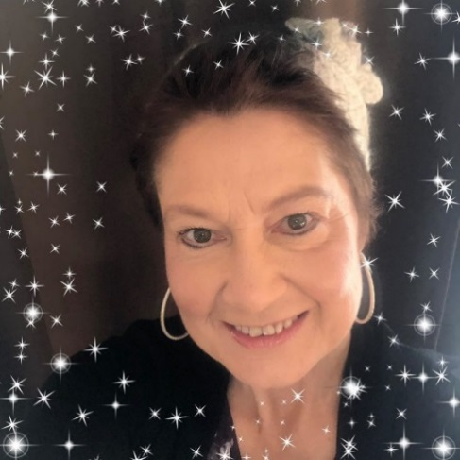  This entire event has changed my life, and my perspective. I am grateful to have made it this far in my recovery in a relatively short time - especially considering my injuries. I am thankful for life. I tend to look more at the optimistic things and ignore things that are not so great. I work hard. I take it easy when needed, too. I still research and study a lot about the after-effects of a TBI. I am more careful. I eat much better, I exercise daily, and I play board games to exercise my brain. I participate in events and activities that stimulate my thoughts and increase my brain’s abilities. I keep in touch with my former housemates at QLI. I adore, love and appreciate all of my family and friends. I received so much support from everyone while I was going through my medical treatment, and I am still receiving their support! To all of the LAW members – thank you so much for the wonderful gifts and for thinking of and praying for me! I truly believe that all of the support I received from everyone helped me persevere through my initial recovery. I am forever appreciative and grateful!

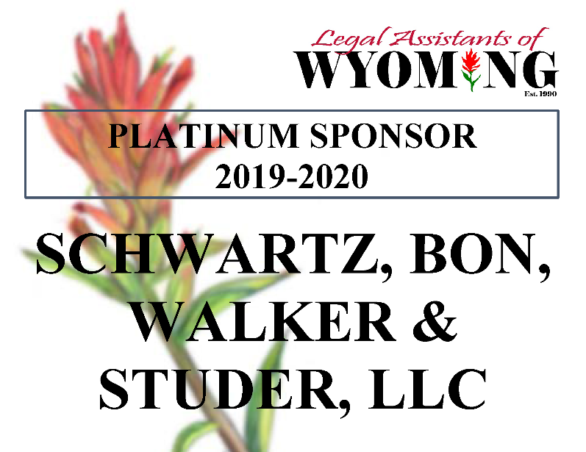
OUR GENEROUS SPONSORS

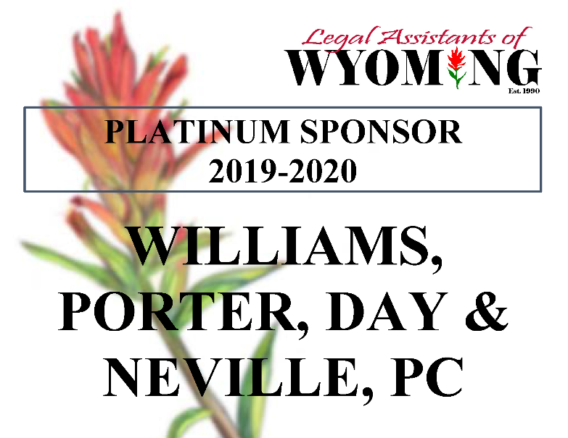
Barbara Heisner, CP  President  After graduating from Casper College with my Associate of Arts degree in Paralegal Studies in May 2015, I became a NALA Certified Paralegal in March 2016.  My legal work experience includes working as a legal assistant for Craig Silva and Kyle Ridgeway at Williams, Porter, Day & Neville, P.C. for four and a half years and as a legal assistant for Ann Rochelle at Rochelle Law Offices, P.C. I currently work at Chapman, Valdez, & Lansing in Casper. I enjoy working in criminal and family law the most.  While attending Casper College I participated in the Casper College Legal Services program, assisting in pro bono work. I was also a member of the Phi Theta Kappa National Honor Society. In 2016, I became a member of the first Casper College chapter of Lambda Epsilon Chi, the National Honor Society for Paralegal/Legal Assistant studies.  I was born in Casper and have lived in Wyoming my whole life. I’m currently working on my bachelor’s degree in Communication. I am passionate about the fine and performing arts. I love traveling, the beach, reading, dogs, and spending time with my friends and family, including my longtime boyfriend Jared and my 10-year old bonus son, Kannon. I am an avid, die-hard St. Louis Cardinals fan!  Thank you for allowing me to serve LAW as the President this term. |  | Amanda Nelson, ACP  President Elect  Hello LAW Members! I am excited to again serve on the Legal Assistants of Wyoming board. I have served on a position on the board for more than a decade, although not consecutively. Throughout those terms, I have served as a Regional Director, 1st VP, 2nd VP, President-Elect, President, Secretary and NALA Liaison (many for more than one term). I love this organization and the services they provide to the profession around the state!  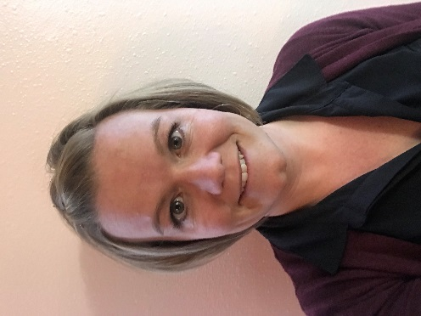  I am employed as the Program Director and Paralegal Instructor for the Casper College Paralegal Program in Casper. Prior to this position, I have worked as a contract paralegal for various attorneys in Casper and Cheyenne, mostly in the domestic relations area, but have some experience in probate, estate planning, criminal law, personal injury and contracts. Additionally, I have provided bookkeeping and billing services to attorneys and an oil and gas landman. I graduated with an AA in Paralegal Studies from the Casper College Paralegal Program in May 2006 and received my CP in July 2007. I obtained my ACP with a specialization in Discovery in 2010. I also hold a BS degree in History from Oregon State University. I plan to begin the Master’s program at the University of Wyoming in Fall 2020 to obtain my Masters in Adult Education.  Aside from working, I am blessed with a wonderful family. I’ve been married to my best friend for over 14 years and we have 4 active children together: Nick (13), Luke (12), Oliver (9) and Norah (5). We love doing things as a family, spends lots of time exploring the outdoors and are highly active in Scouting of America and 4-H.
MEET THE LAW BOARD

OUR GENEROUS SPONSORS

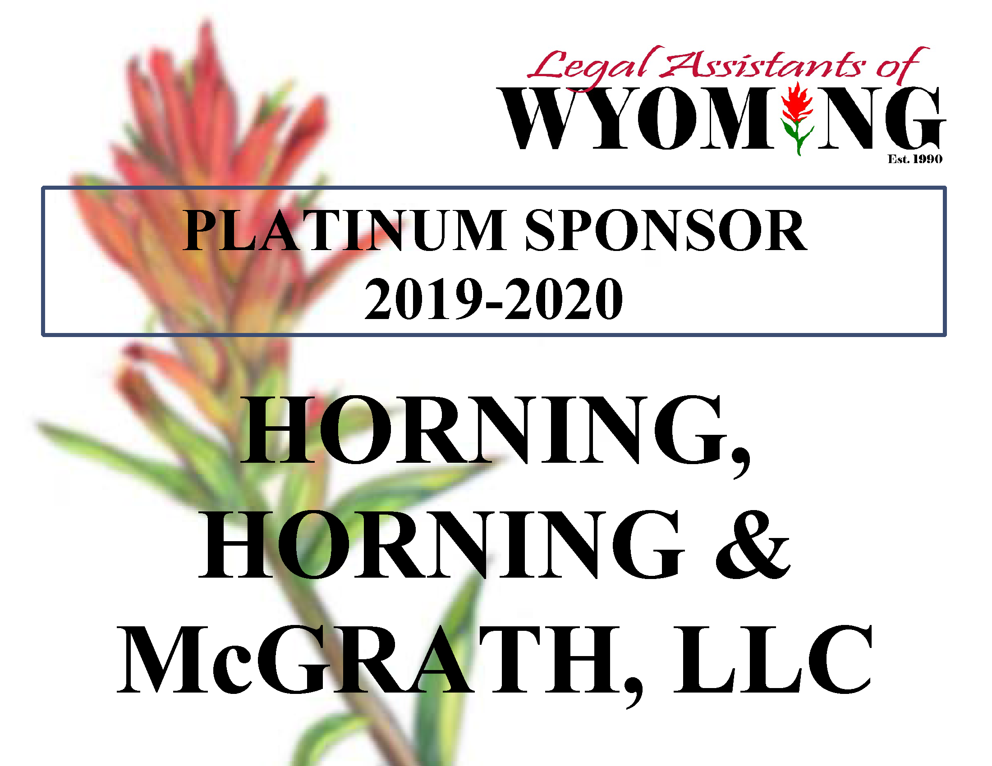

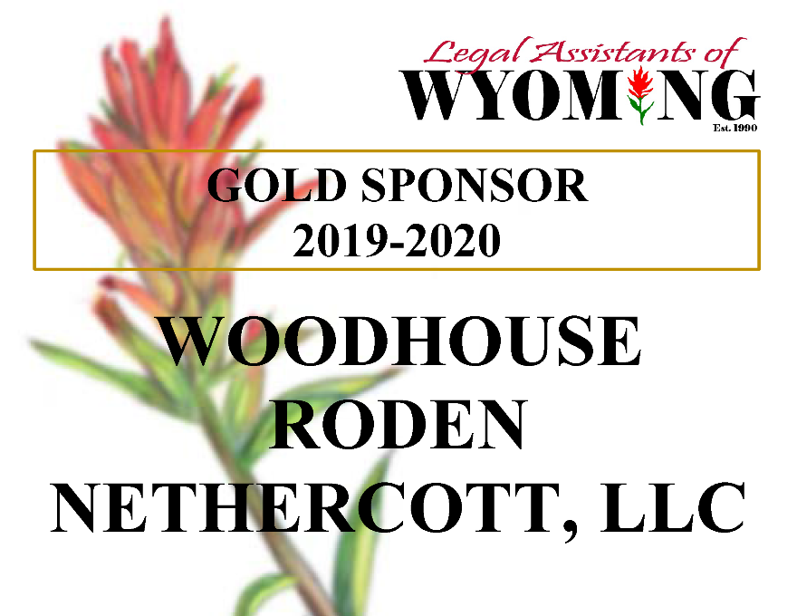

Tis the Season… of Awkward Gift Giving
  - By: Amanda Nelson, ACP
  - President Elect 2019-2020

Are you one of those individuals who struggle to find that “perfect” gift for your boss, co-workers or general acquaintances? It’s difficult to know how personal or impersonal to get, especially when you feel a gift will be expected! Don’t add to your holiday stress. Take advantage of others’ hard work! Every year lists are compiled of suggestions for the best holiday gifts for your coworkers and office mates ~ and we are providing those to you! The following gifts ideas were compiled by Today.com. The list provides options for tech-loving, food-loving or unique-gift-loving in all prices ranges.

I. For tech-loving coworkers:  • Jastek Charger Kit - This universal travel charger kit allows individuals to be prepared wherever they go! The set includes “a charger, power bank and multiple cables for plugging in a range of devices”, all while being stored in a sleek zipper-pouch bag. Available at Amazon for $24.99.  • Sony Noise-Canceling Headphones - Noise canceling headphones are always useful for those who have a hard time focusing. These headphones are comfortable and come with a one-year guarantee! Available at Best Buy for $36.00.  • Echo Dot - this voice-controlled small speaker is the next best thing to a personal assistant! It comes in “four shades, it can provide meeting alerts, check the weather, read the news, play music and more.” Available at Amazon, Target or Best Buy for $34.99.  • Anker SoundCore Bluetooth Speaker - Great gift for the coworker who loves to listen to music! This tiny portable speaker “can play up to 24 hours on a single charge”! Available at Walmart for $27.99. |  | II. For beauty, health and wellness-loving coworkers:  • Tarte 9 Ways to Shine Cheek Wardrobe - Tarte’s holiday collection cheek wardrobe includes “three sleek stacks, each containing a complementary (and long-lasting!) bronzer, blush and highlighter”. It’s the complete set and sure to be a hit! Available at Ulta, Sephora or Macy’s for $35.00.  • Kiehl’s Hydration Essentials Gift Set - This hydration set includes the Ultra Facial Cleanser, Ultra Facial Cream, Creme de Corps and Lip Balm, and is sure to keep any skin moisturized in this Wyoming winter wind! Available at Ulta, Macy’s and Bloomingdales for $30.00.  • Savvy Infusion Water Bottle - Help your coworker’s stay hydrated with this infusion water bottle. Just add frozen or fresh fruit, along with flat or sparkling water for a hydrating, fruit-flavored water break. Available at Amazon for $15.95.
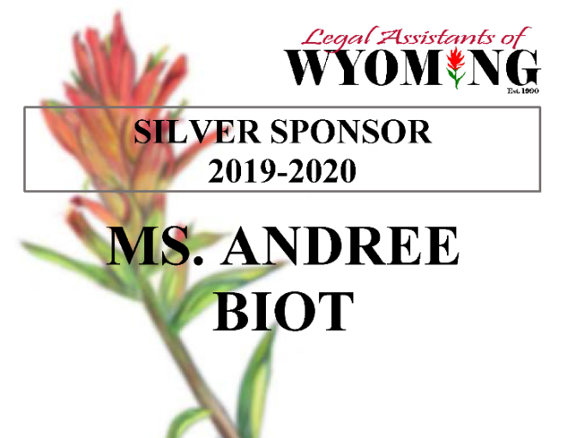
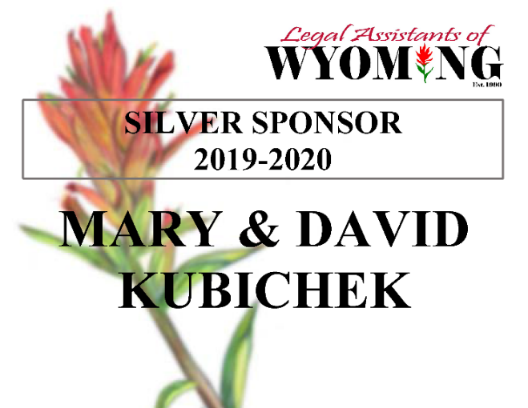

Tis the Season… of Awkward Gift Giving (cont’d)

III. For food-loving coworkers:  • Happy Holidays Assorted Chocolate Box - This is a limited-edition collection containing a “rich assortment of hand-cut, hand-blended and certified-kosher chocolates.” This is a perfect gift for your chocolate-loving coworkers! Available at Williams Sonoma for $29.95.  • Harry & David Meat and Cheese Sled Gift - This sled provides all the essentials for a savory snack session in style! Available at Harry & David for $59.99.  • Popcornopolis Gourmet Popcorn Gift Basket - This basket contains five delicious flavors in generous portions and is perfect for sharing around the office! Available on Amazon for $39.99.  • Tea Forte Tea Assortment - Skip the coffee this year and give your tea-loving coworkers a beautiful gift box full of assorted teas! “The sampler includes twenty individual pyramid tea infusers for twenty days of tea time bliss”! Available on Amazon for $34.99.  IV. For clothing and accessory-loving coworkers:  • Bombas Compression Socks - Guaranteed to keep blood flowing, provide comfort and be in style, these socks provide added support for those with desk jobs. Bonus - the company donates a pair to the homeless community with every purchase! Available at Bombas for $18.00.  • LifeArt Blue Light Blocking Glasses - These glasses help protect your eyes from blue light rays, and are perfect for those who make their living in front of a computer screen. We don’t know anyone like that, do we?! Available in varying styles and magnifications on Amazon for $19.95. |  | V. For unique gift-loving coworkers:  • 2020 City Maps Wall Calendar - This wall calendar allows your coworker to escape, if only momentarily, with maps of all the major cities. This brand also has lots of travel-themed calendars and planners for smaller office spaces. Available at Anthropologie for $19.50.  • Otterbox Elevation Tumbler with Hydration Lid - This lifetime guaranteed insulated steel tumbler is sure to be useful to anyone. It maintains the ideal temperature for hot or cold drinks and is available in a variety of colors and sizes! Available on Amazon or at Otterbox for $29.99.  • USB Desk Fan - Office building struggle to find the ideal temperature? This desk fan is USB powered and provides two speeds for maximum comfort! Available on Amazon for $16.99.  • Dinosaur Ceramic Succulent Planter - If you have a green thumb, or don’t, this adorable dinosaur succulent planter provides a little green to brighten anyone’s day! Available on Amazon for $10.93.  Whatever your budget or preference, there are fun and thoughtful gifts available! Merry Christmas, and happy shopping!  Original list received and modified from: Krisin Granero and Chassie Post, dated 11/20/2019, https://www.today.com/home/25-awesome-gift-ideas-your-co-workers-or-your-boss-t119369

MEET THE LAW BOARD
  - Annette Sause
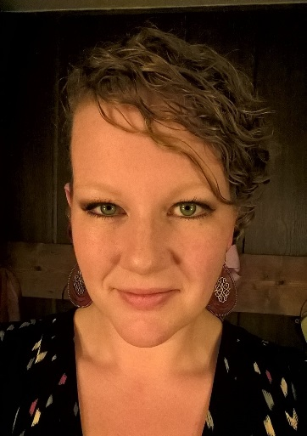
  - 1st Vice President

  - I was born and raised in New Jersey. After graduation and a stint as a nanny in New York, I met my husband in Colorado in 2004 and we decided to move to his hometown, Casper, in 2008. I graduated Casper College’s Paralegal Program in 2017 with a 4.0. While in the program, I served as LAW’s student liaison, and was honored to receive LAW’s 2016 Outstanding Student Award. I was inducted into Phi Theta Kappa Honor Society, and began the legwork for creating a brand-new chapter of Lambda Epsilon Chi Paralegal Honor Society at Casper College. It was amazing to have had a part in the creation of Wyoming’s first and only chapter of LEX, and to become a charter member. In 2017, I received LAW’s Future CP Attainment Award. My first official paralegal position was with Dixon & Dixon in 2017-2018. In 2018, I was elected to the LAW board as Secretary.

  - I am currently employed as receptionist/legal assistant at Chapman Valdez & Lansing, Attorneys at Law. I work with some amazing people, and there is never a dull day! I very much enjoy the “people person” aspect of my position. I am also an ordained minister and have officiated 150+ weddings over the years. Clients trust me to write and perform custom, legally binding ceremonies. Especially during wedding season, you can find me researching, writing ceremonies, at consultations with clients, at rehearsals, filling out paperwork, calming brides (and/or grooms!), fetching forgotten items at the last minute, and a million other unforeseen tasks. I don’t have many free weekends, but I wouldn’t trade it. It is one of the happiest, most exciting, and most fulfilling jobs in the world.

  - My husband Josh works for National Oilwell Varco/Tuboscope, and is frequently working out of town in such places as Texas, Kuwait, and the Netherlands. We have two children: Paili Jean (10), and Ollie Dean (7). We love spending time as a family outdoors: camping in the Shirley and Bighorn Mountains, gold panning/gem hunting in our “secret” spots, and cross-country road trips.

Thanks, LAW! I’m honored to have been elected your 2019 1st Vice President. Here’s to a great year!

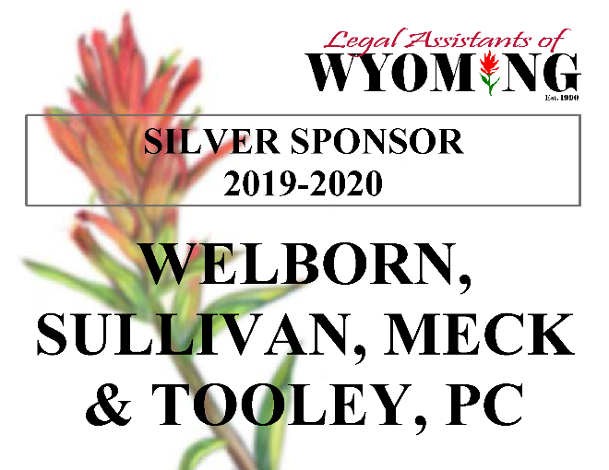
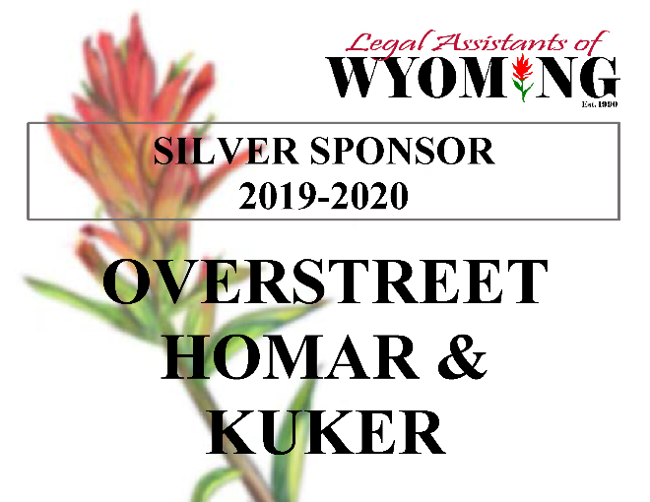

LAW FALL SEMINAR HIGHLIGHTS
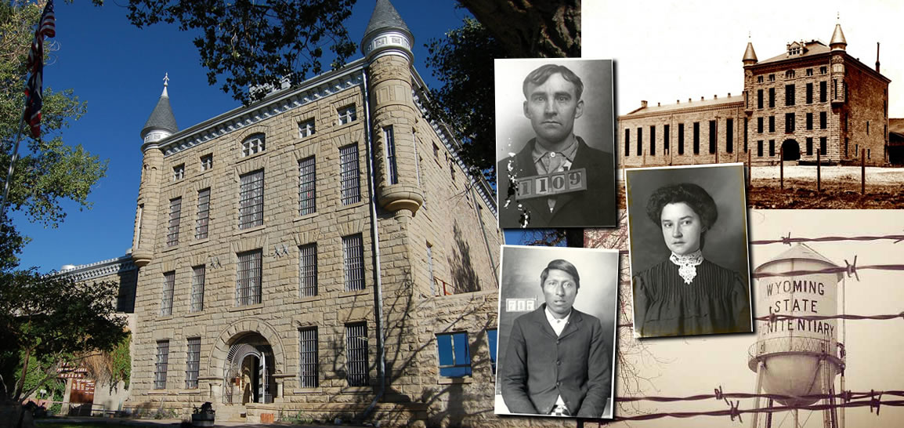
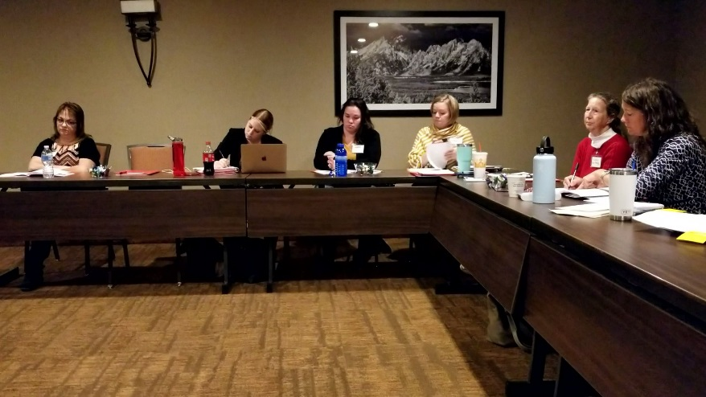
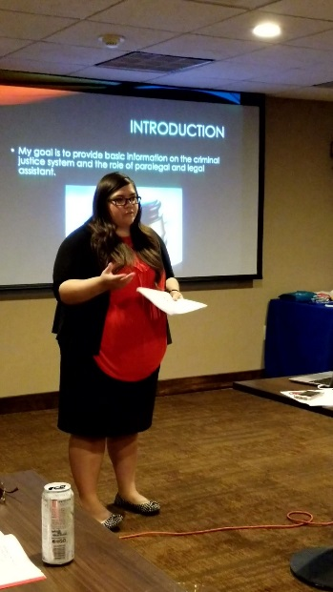
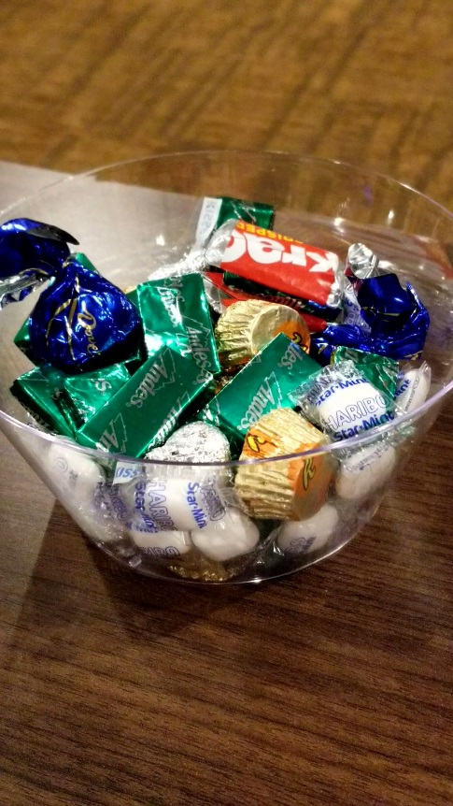
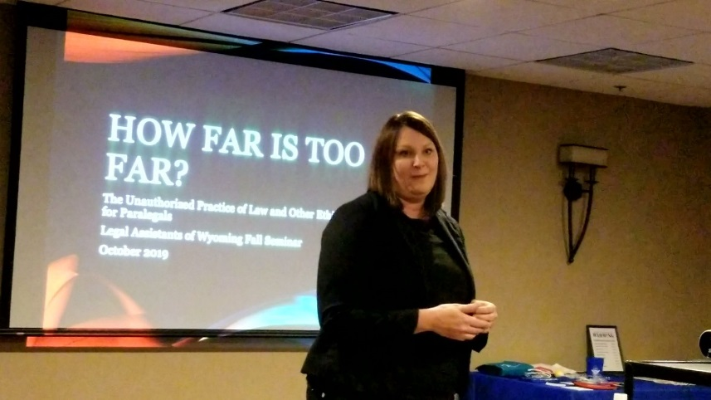
MEET THE LAW BOARD

  - Kathy Lackey
  - 2nd Vice President

  - I graduated from the University of Wyoming with a degree in Secondary German Education because I really did not know what I wanted to do when I grew up. My search continued, and eventually I found myself working at the (then) Natrona County Court as a clerk for a few years. Life continued to take various turns until I landed in Cheyenne. I worked for the Fitzgerald Law Firm for several years as a legal assistant. In 2015 I began working at Woodhouse Roden Nethercott, LLC and now work primarily as the paralegal for Gay Woodhouse.

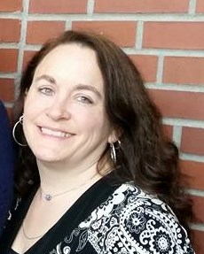
  - My husband and I have a combined his/hers family which currently consists of 5 daughters/1 son-in-law/1 granddaughter and 1 dog. We still have two busy teenagers at home which means much of our “spare” time involves chauffeuring girls to/from school/practices/events and so on. We love the chance to spend rare evenings on our couch together for family movie nights. Occasionally I manage to enjoy running 5ks and reading for pleasure.

  - It’s an honor to serve LAW as the 2nd Vice President. I am excited for what this next year has to offer.

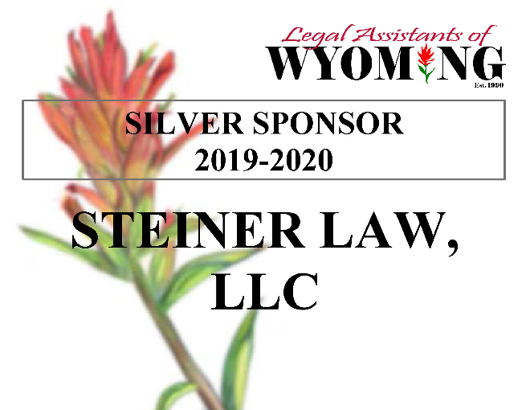

Kapri Scoffield
Secretary

Hello LAW members, my name is Kapri Scoffield! I am excited to serve on the Legal Assistants of Wyoming board. I was the Student Liaison last year. So, I am super excited to be an active board member!

I am employed as a paralegal at Engelhart Law and Brown Law Office. This is my first actual paralegal role since completing the program at Casper College. I worked as an Administrative Assistant at Legal Aid of Wyoming for almost two and a half years. I graduated with an AA in Paralegal Studies from the Casper College Paralegal Program in May 2019. I am currently going for my bachelor’s degree in Criminal Justice through the University of Wyoming. Once I have completed my bachelor’s degree, I plan on going for my master’s degree in social work. My end goal is to work as a forensic social worker and possibly become an expert witness for court on child abuse and neglect.

I also have three wonderful children: Taylen, Maci, and Trevyn. They tend to keep me pretty busy. They are all very active in activities at school as well as activities in the community.
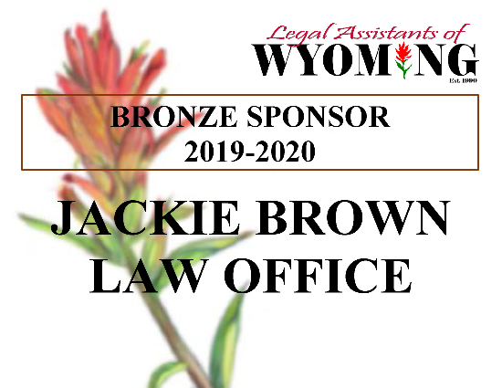
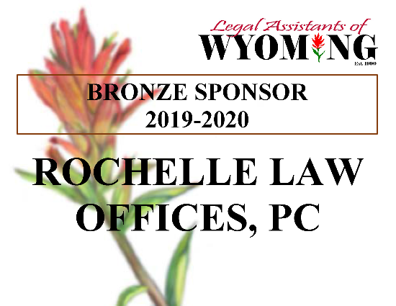
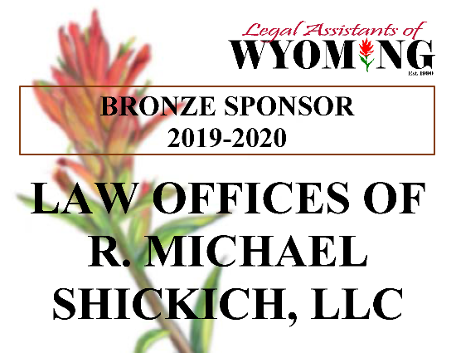
MEET THE LAW BOARD
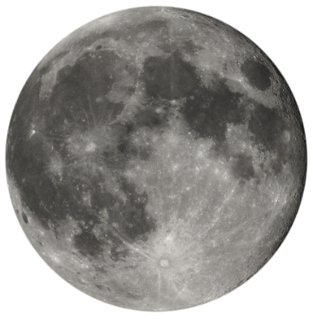

MEET THE LAW BOARD
Jayme Bjorklund, ACP  Treasurer  Jayme is a Commercial Lines Account Manager with USI Insurance Services as well as a free-lance paralegal, JRB Integrity Services. She earned her paralegal certification from the Casper College ABA program in 2009 as well as her CP designation, and earned her ACP designation in Discovery in 2011.  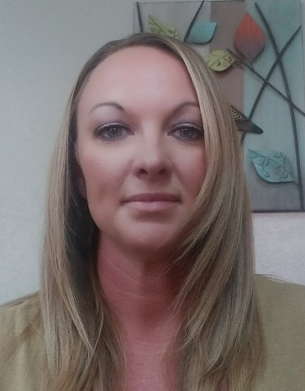  Jayme has worked in the legal field for more than 20 years, beginning as a 911 dispatcher at the age of 19. From there she worked for the Natrona County Circuit Court for five years before she was approached by Stacy Casper to join her team at Casper Law Office, LLC. She went back to school and earned her AA in Paralegal Studies as well as her CP designation. Jayme loved working for Casper and loved the family law realm. She continued working full time for Casper until she and her family moved to Oklahoma in 2011.  Oklahoma was a very different dynamic for Jayme as a paralegal, as she struggled to find a law firm that would utilize her skills. With no luck, she took on a data entry job with Special Metals, Inc. and rose to Receiving Coordinator. |  | She also did remote work for Casper Law Office, LLC periodically throughout the eight years she was in Oklahoma.  After four years out of the legal field and missing the law realm, she went to work at Angela Ailles and Associates, an insurance defense firm and corporate litigation counsel for State Farm Insurance. After two years and a wealth of new knowledge, she returned with her family to Casper. As you know, finding a law firm that will provide benefits is pretty scarce in these parts and it’s something she had to have. Until she found USI, she worked for Michael Shickich, but plaintiff’s personal injury litigation was just not her cup of tea. USI Insurance is her home for now and where she is thriving, currently passing her insurance exam and moving on to more insurance certifications.  Jayme also has a free-lance paralegal business, JRB Integrity Services, where she focuses her work on family law. Currently she has two attorneys that take up the majority of her free time with free-lance work.  Jayme is married, with two children 27 and 14 and a new grandmother to a beautiful little boy. Jayme enjoys spending time with her family as well as hiking and camping, something she missed doing in Oklahoma.  Jayme has been a member of LAW off and on since 2009 and has served one previous term as LAW Treasurer in 2011, prior to moving to Oklahoma. She is very excited to be involved again with the organization and looks forward to the fun and activities of this year’s term as Treasurer.
MEET THE LAW BOARD

Wendy Trembath, CP  NALA Liaison  This term, I am the NALA Liaison, which has truly been an honor and pleasure. I attended the NALA Convention in Scottsdale, AZ in July. Please see my NALA Convention summary article in this newsletter.  I have worked as a litigation paralegal at Williams, Porter, Day & Neville since 2015. My position was made possible by knowing someone at the firm – through LAW – who put in a good word for me when the firm was hiring paralegals. The networking is one of the best benefits of being a member of LAW.  I have greatly benefitted from my LAW membership in other ways as well. I won the Outstanding Student scholarship in 2007, and won the CLA/CP Attainment scholarship in 2008. I was LAW’s Secretary in 2014-2015, Treasurer in 2017-2019, and have chaired the Awards Committee for many years. I also like technology and have been on the Website Committee for several years.  I was born and raised in Colorado. I have a Bachelor’s degree in Broadcast Journalism. I met my husband, Wallace, in college at CU-Boulder. We got married in Guam, USA where I worked as a radio and TV news producer, reporter and anchor for three years. I continued as a radio broadcaster for KSL in Utah, and then we moved to Oregon where Wallace went to law school at the University of Oregon in Eugene. |  | In June 2005, Wallace opened his own law firm in Casper. I was to assist him as his paralegal, but I didn’t have a clue! By August 2005, I was enrolled in the Casper College Paralegal Program. The program was critical to our success with the firm. After a few years, Wallace took a position at the City of Casper Attorney’s Office where he is now the Deputy City Attorney (Civil). I worked for seven years for personal injury attorney R. Michael Shickich. In the meantime, I graduated with my Post-Baccalaureate Paralegal Certificate in May 2008, and passed my CLA/CP Exam in July 2008.  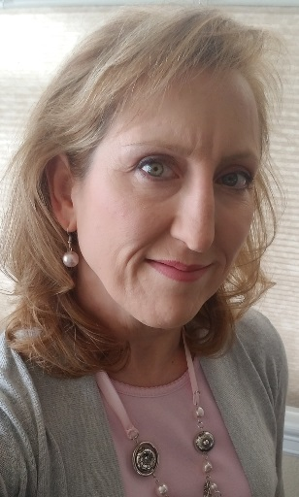  Wallace and I will have been married 28 years in January. Instead of having kids, we decided to be active adventurers. We have enjoyed scuba diving and snorkeling in exotic locations like Palau, Bali, Belize and Fiji. We spend many of our summer weekends whitewater kayaking the rivers of Wyoming and Colorado, and we plan to travel to Costa Rica in the next few years for whitewater kayaking. We downhill and cross-country ski in the winter. I also enjoy hiking, growing flowers, coloring, making jewelry, and home decorating. We also enjoy lounging around watching Broncos football with our cat, Oliver. We serve as Pre-Marital Mentors at our church. I also perform often in my church’s musicals, skits and choral productions.

NALA NEWS

Recent Changes Improve NALA Benefits

  - By: Wendy Trembath, CP
  - NALA Liaison 2019-2020

NALA is working to improve member (and non-member) benefits! Here is a synopsis of some of the recent changes.

New Benefit for Paralegal Students: If you are a current paralegal student, the time has never been better to apply to take the NALA CP Exam! Paralegal students who are in their last semester or quarter of the program, with proof, will be allowed to apply for the CP exam at a significantly discounted rate!

Paralegal students, with proof, will have a Student application fee of:
- $125 for NALA members (This is half off the Active Member rate of $250!)
- $150 for non-members (Savings of $125 off the Active Member rate of $275!)

Again, you do not have to be a NALA member to take advantage of this significant discount!

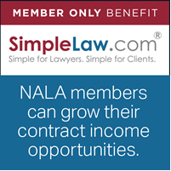
NALA has Partnered with SimpleLaw: If you are a contract paralegal, listen up! NALA has established an exclusive partnership with the cloud-based case and practice management platform SimpleLaw. NALA members can use this platform to grow their contract income opportunities. SimpleLaw uniquely connects attorneys with on-demand paralegal support right through the platform with no additional fees. NALA member paralegals have exclusive priority with attorneys who request support through the SimpleLaw platform. Go to https://www.nala.org/SimpleLaw to learn more about this exclusive benefit.

Free CLEs for Active Members: Members with an Active Membership have exclusive access to the following CLE courses for free. By completing these courses you can earn up to 5.75 hours of CLE credit!

On-Demand Webinars:  Dealing with Difficult People  Managing Stress in a Turbulent World  School Safety: From the Schoolhouse to the Courthouse  The Science of Living in Balance  Using Coaching Skills to Improve Communication | Self-Study Courses:  Leadership Basics

Earn CLE for Published Articles: Certified Paralegals can earn CLE credit if they submit an article for Facts & Findings and it is published. Hours may be awarded for publishing an article of at least 1,000 words in a legal periodical or book on a subject of substantive law or procedure related to the work of paralegals. CLE will only be granted once the article has been approved by the Facts & Findings Editorial Board.
NALA NEWS (cont’d)

Earn CLE for Reading F&F Articles: As of August 1, 2019, CPs are no longer required to complete a test after reading Facts & Findings articles in order to receive CLE credit. CLE must be submitted within one year of the publication date. No other publications will be considered. Certified paralegals may submit up to two hours of CLE per year, with a maximum of five hours of CLE per each five-year certification period.

Affinity Discount: As a member of NALA, you receive exclusive local and national discounts on hundreds of products and services. To access these deals, login to your NALA account and then go to the Affinity Discounts page.

NALA Convention – Affiliate Showcase Summary
  - By: Wendy Trembath, CP
  - NALA Liaison 2019-2020

The NALA Convention July 11-13, 2019 was held in Scottsdale, Arizona. When I arrived at the airport around 10:00 p.m., it was still 108 degrees! I quickly learned how gigantic the beautiful Westin Kierland Resort & Spa truly was… room service is delivered by Segway!
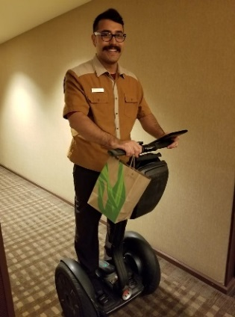
Thursday was dedicated to NALA business - the keynote speaker, the Affiliated Associations Annual Meeting & Awards, a humorous session called “Confessions of a Stressed-Out Paralegal,” and then the Affiliate Showcase. This is where NALA Affiliates from all over the country set up booths and offer “swag” to members of fellow affiliates. (We gave away hand sanitizer pens with our LAW logo on them.)
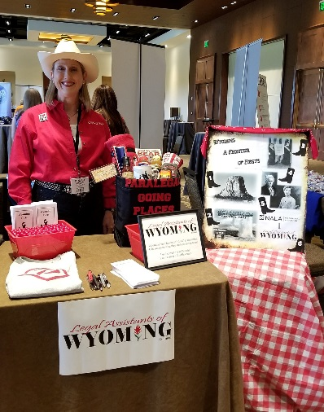
I went with a Western theme, and had a contest called “Wyoming… a Frontier of Firsts.” The prizes were a “Super Paralegal” t-shirt and a “Paralegal Going Places” tote filled with Wyoming-made products. The contest was to guess 4 out of 6 “Wyoming Firsts” based on pictures on a board. Wyoming had the first National Park (Yellowstone), the first National Monument (Devil’s Tower), and it was the first place in the country women could vote. Wyoming had the first female governor, the first female justice of the peace, and LAW was the first (and is still the only) Affiliate of NALA in the state. Many paralegals played the game and won an entry for the drawing and learned a little about Wyoming along the way. I drew the winners after the showcase and delivered their prizes the next day. It was fun (and exhausting), and I think LAW made a good impression!

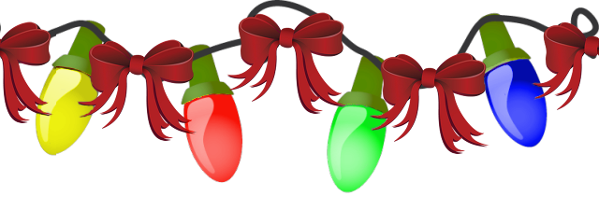
MEET THE LAW BOARD
Savannah Hernandez  Region 3 Director  Hello LAW members! I am so excited to be on the board again. I am the region 3 director and I am looking forward to meeting all the new members as well as working alongside a great board.  I am a full time paralegal at Reece Law, LLP where I primarily work on family law matters. I graduated from Casper College with my degree in paralegal studies in 2017 and I have been working in the legal field for approximately four years. I began at Legal Aid of Wyoming. I then worked for Kathleen & Pat Dixon at Dixon & Dixon, LLP, and I worked for the Clerk of District Court briefly before returning to Dixon & Dixon, LLP.  I married my amazing husband on July 27, 2019; next year we will be celebrating seven years together. In 2020 I will be attending the University of Wyoming and working towards my bachelor’s degree. |  | Tylor Roybal  Region 4 Director  I currently work at Woodhouse Roden Nethercott, LCC, as a paralegal. I absolutely love it there. It’s not often you enjoy working with your “work family” eight hours (or more) a day, but I do. The atmosphere is healthy, and my co-workers all have their own quirkiness and spunk, which makes for some hilarious days. I work under three attorneys; their caseloads vary from criminal, family, probate/estates and everything in between. I think my favorite type of work is adoptions. Being able to work one on one with the families, seeing them get excited about name changes and making a kiddo part of their forever home brings me so much joy.  Prior to working at WRN, I worked for the Laramie County District Attorney’s office as a legal assistant overseeing the neglect, CHINS and delinquency docket. I worked closely with the courts, the Department of Family Services, and some other really great community based resources.  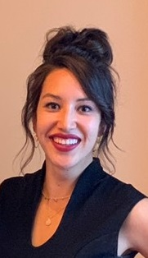  I was born and raised in Cheyenne. I met my husband, Phillip, in high school and we are about to celebrate 13 years together. We have two dogs; Ellie is my grumpy Shi tzu and Marty is the most loving pit-bull mix you will ever meet. Phillip works full time for the Wyoming Air National Guard. Most weekends you can find us at the gym, doing yard work or hanging out with our closest friends.  I appreciate the vote to be LAW’s Region IV Director and hope to bring some new and fun ideas to the table!

Region 3 Halloween Party

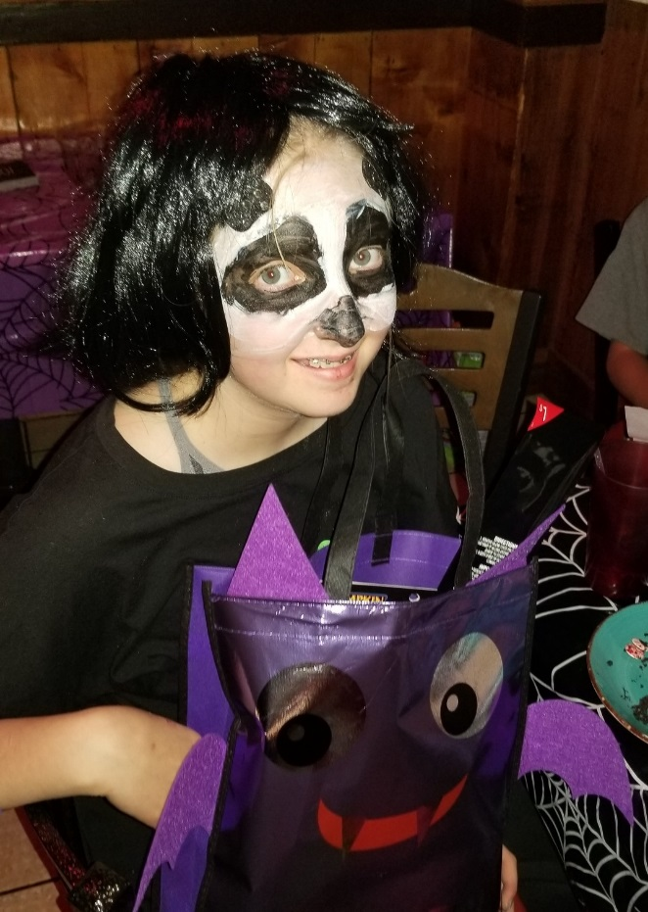
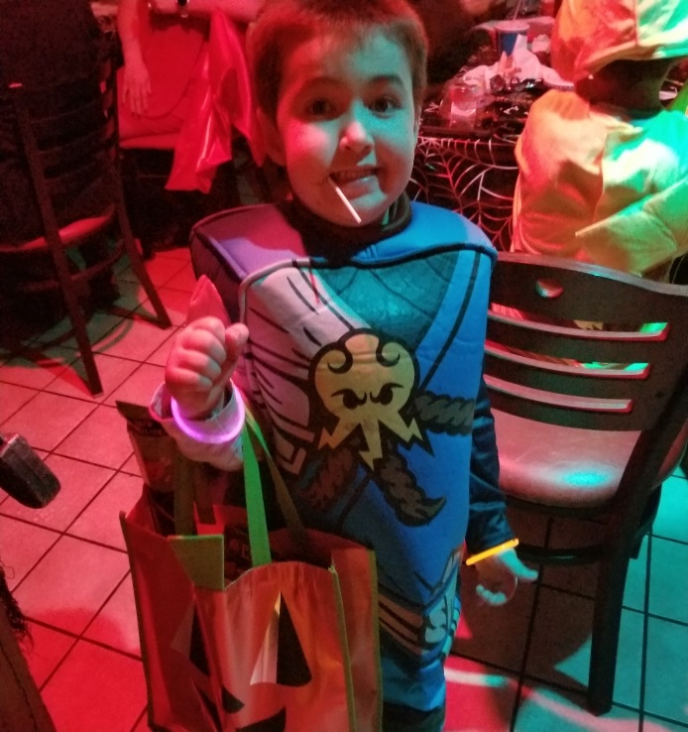
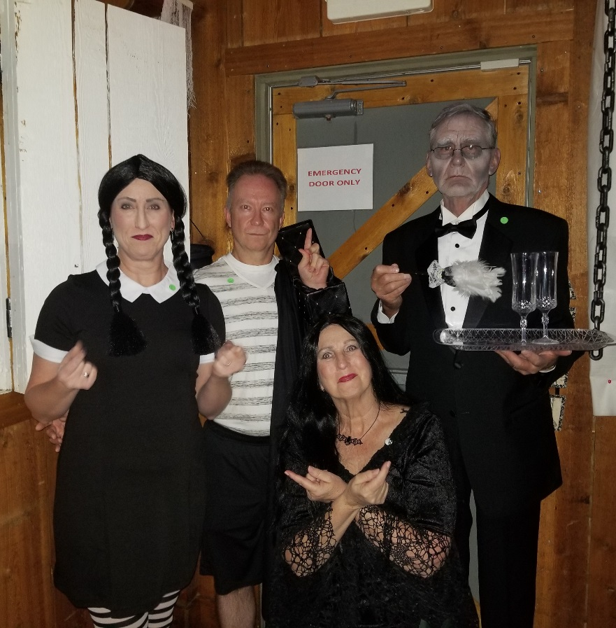
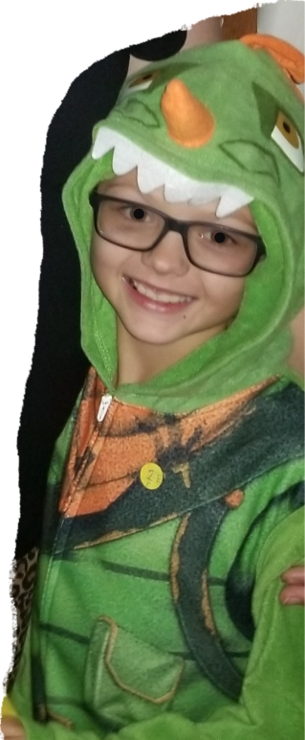
Co-Winners – Scariest
Pikachu and Dinosaur
Winner – Most Creative
Panda
Winner – Funniest
Lego Ninja
Winners – Best Group
The Addams Family

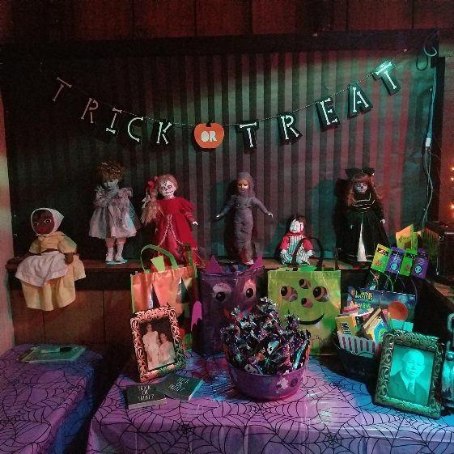
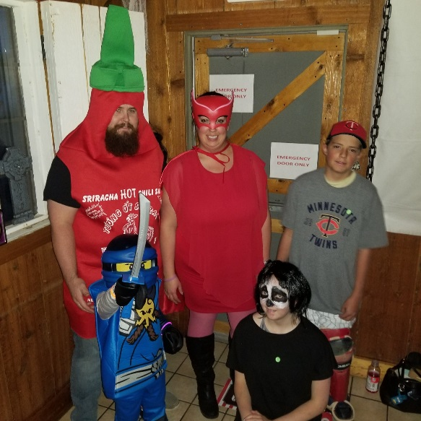
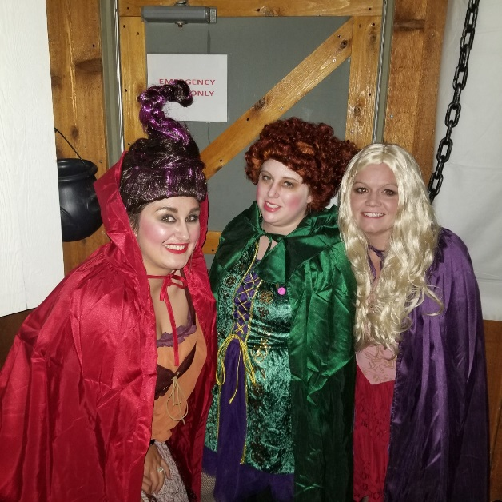
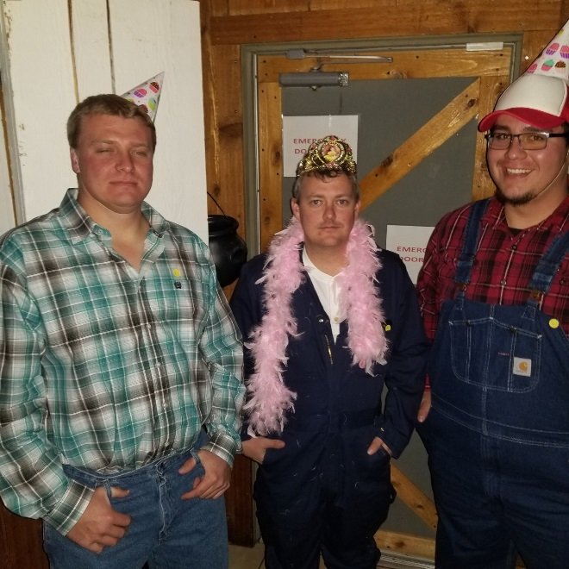
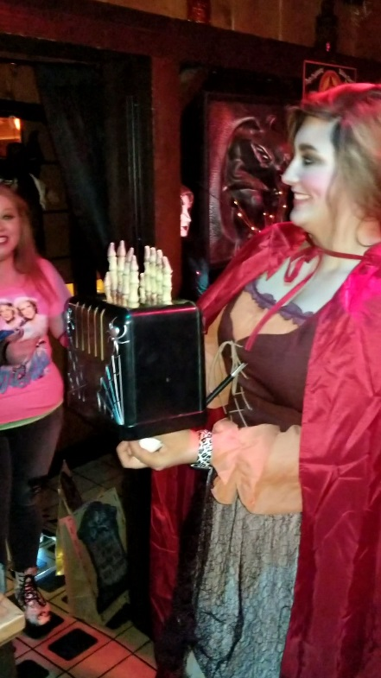
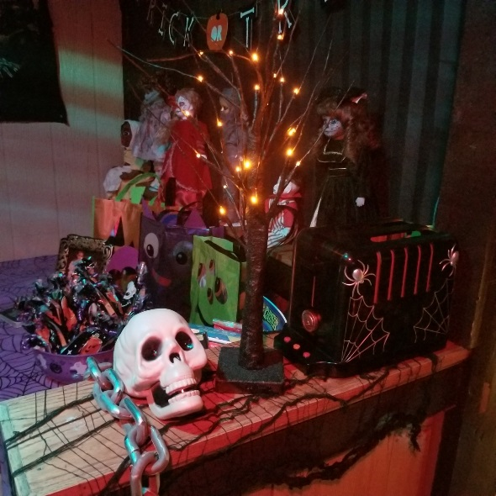
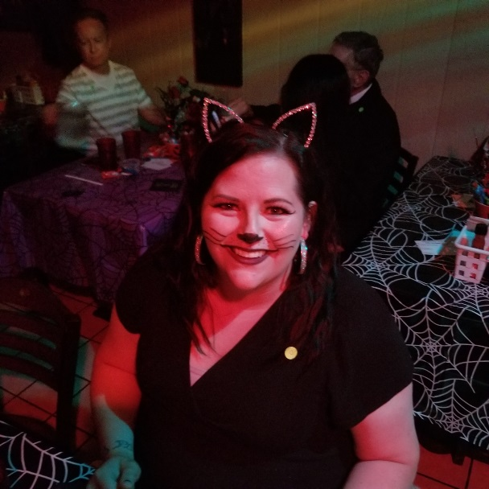
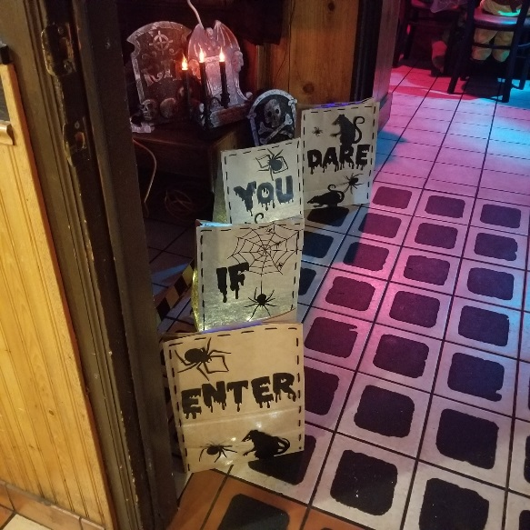
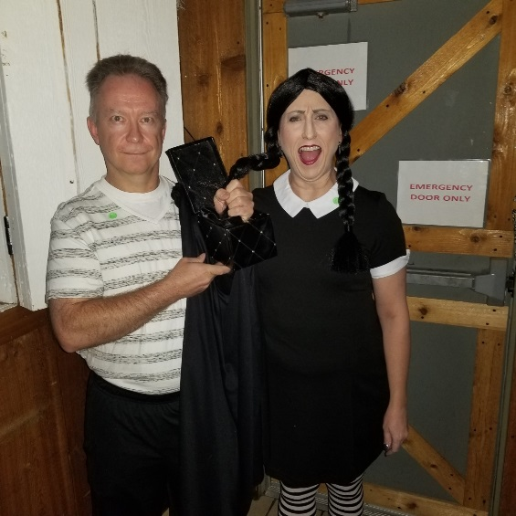
Region 3 Halloween Party (cont’d)
Region 4 Christmas Potluck & Toys for Tots Drive
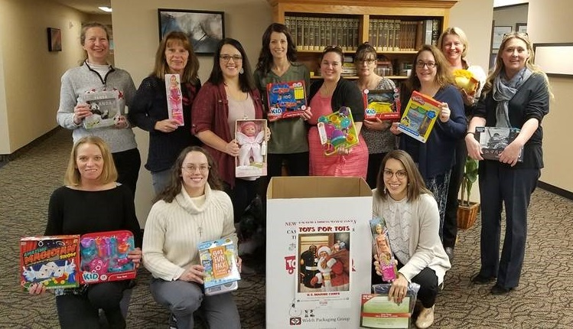

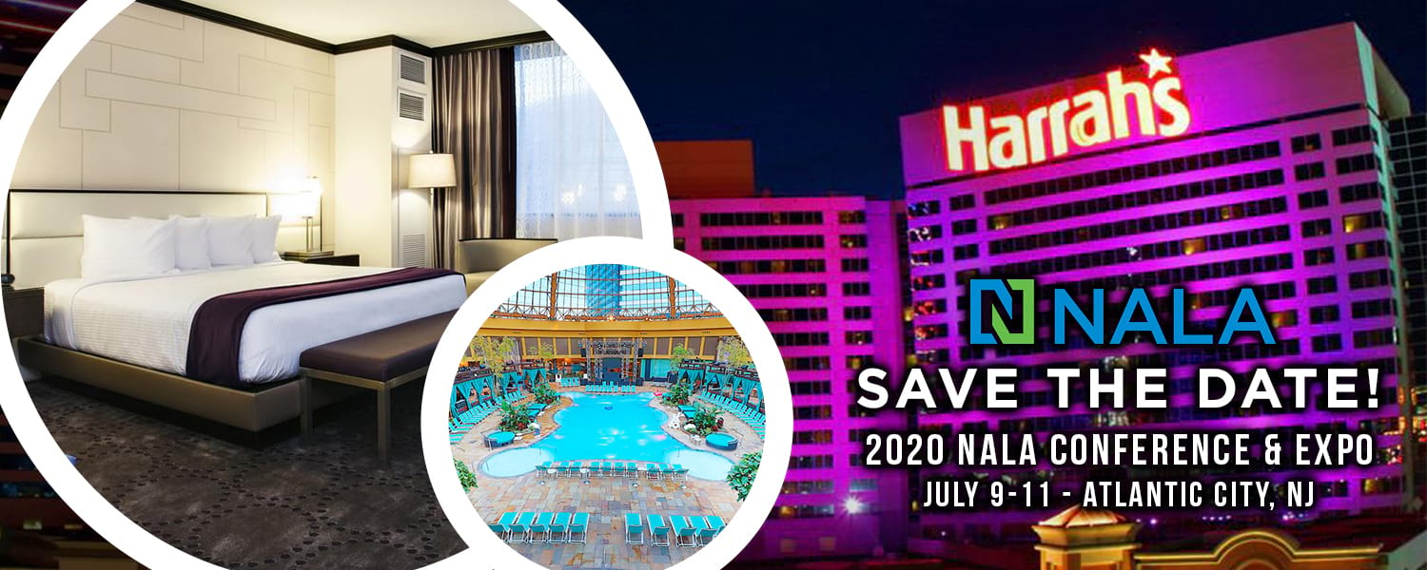

MEET THE LAW BOARD
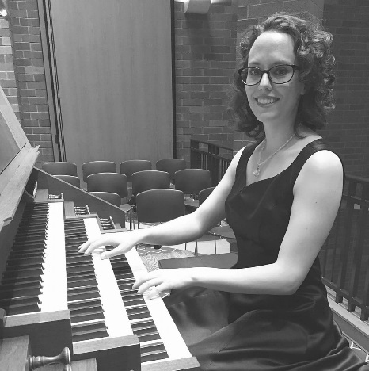
Stephanie Barth
LCCC Student Liaison

Stephanie Ann Barth, MM, CAGO studied at Duquesne University (magna cum laude) and the University of Oklahoma. She currently lives with her husband and their cat Norman in Cheyenne, WY. She will finish the LCCC paralegal program in December 2019. She works as a paralegal at Sundahl, Powers, Kapp & Martin in Cheyenne.

Stephanie plays the organ for St. Matthew’s Cathedral in Laramie, WY and St. Mary's Cathedral in Cheyenne, and maintains a private music studio.

DATE | DEADLINE
March 1, 2020 | Applications for CP Attainment Award Due
March 1, 2020 | Applications for Outstanding Student Award Due
April 1, 2020 | Awards Committee to select award recipients
April 17-18, 2020 | Spring Seminar and Annual Meeting in Sheridan

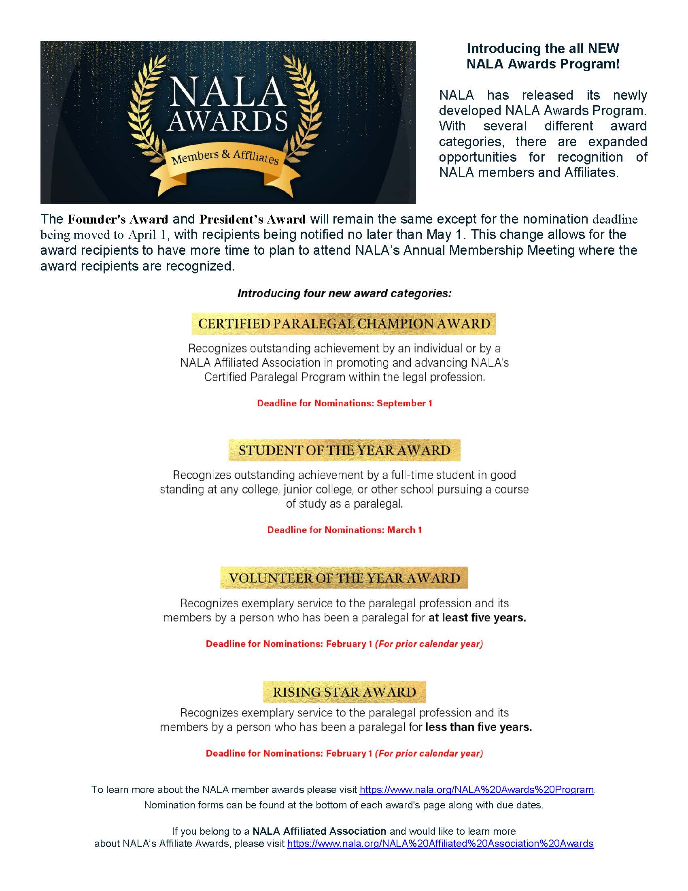
LEVEL / AMOUNT: | BENEFIT FROM 9/1/19 THROUGH 8/31/20:
DIAMOND / $500 | - Firm / Attorney receives a Sponsorship Plaque.  - Firm's / Attorney's name and information on display at registration tables for all LAW events.  - Firm's / Attorney's name and information in LAW's quarterly newsletter. (3" x 5")  - Firm's / Attorney's website link on the LAW website.  - One free Associate Membership to LAW.  - Two coupons for free seminar registrations for anyone. (Must present coupon at registration.)
PLATINUM / $350 | - Firm / Attorney receives a Certificate of Sponsorship.  - Firm's / Attorney's name and information on display at registration tables for all LAW events.  - Firm's / Attorney's name and information in LAW's quarterly newsletter. (3" x 5")  - Firm's / Attorney's website link on the LAW website.  - One free Associate Membership to LAW.  - One coupon for free seminar registration and one coupon for 1/2 off seminar registration for anyone. (Must present coupon at registration.)
GOLD / $200 | - Firm / Attorney receives a Certificate of Sponsorship.  - Firm's / Attorney's name and information on display at registration tables for all LAW events.  - Firm's / Attorney's name and information in LAW's quarterly newsletter. (2" x 4")  - Firm's / Attorney's website link on the LAW website.  - One free Associate Membership to LAW.  - One coupon for free seminar registration for anyone. (Must present coupon at registration.)
SILVER / $100 | - Firm / Attorney receives a Certificate of Sponsorship.  - Firm's / Attorney's name and information on display at registration tables for all LAW events.  - One free Associate Membership to LAW.  - One coupon for half off seminar registration for anyone. (Must present coupon at registration.)
BRONZE / $50 | - Firm / Attorney receives a Certificate of Sponsorship.  - One free Associate Membership to LAW.
It is not too late! Sponsor today and get 8 months of benefits, including coupons for Spring Seminar discounts.
SPONSORSHIP
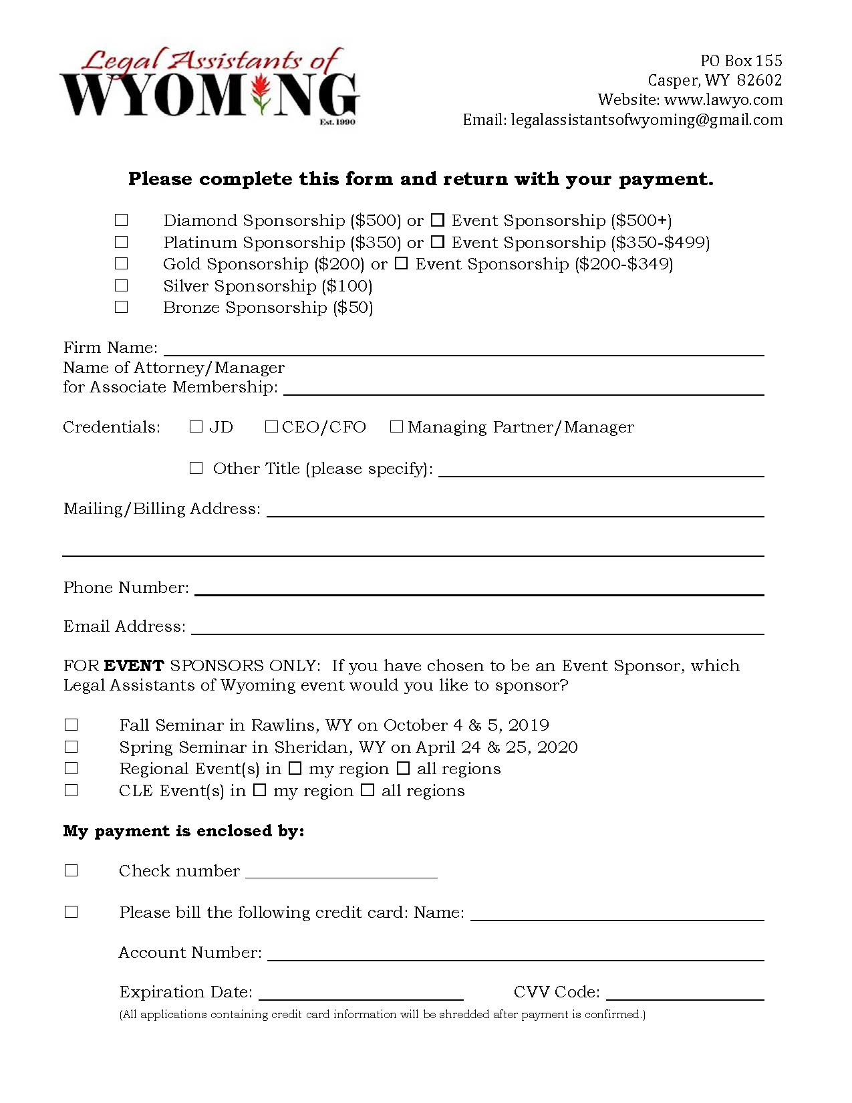
SPONSORSHIP

